NAME: _____________________________________

Sunday, May 1, 2016

**STEWARD:** a person who has charge of the household of another.

**SANCTIFIED**: someone or something that is set apart for a special purpose.

SET APART FOR GOD’S PURPOSE

For the past few weeks, we have been studying the life of Daniel. We heard about Daniel interpreting dreams, being thrown into a lion’s den, and being hated by his enemies for doing good. Daniel was set apart by God to do a specific work in His kingdom. He showed others that they do not have to fear what may happen as long as you continue to put their faith in God. God NEVER lets us down even when things don’t go our way. He has a perfect plan for us and wants the best for our lives. We learn from Daniel that we must trust God, even when we can’t see what the outcome of a situation may be.

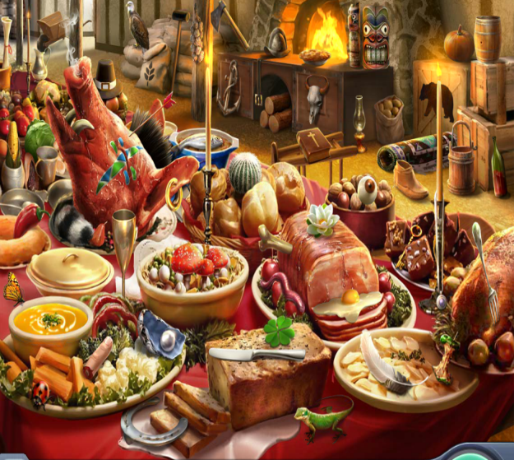Even in the midst of exile and enslavement, Daniel refused to eat food sacrificed to idols. Daniel knew that partaking in anything sacrificed to idols would displease God. He was set apart for God’s purpose and did not want to do anything that would jeopardize his relationship with God. Do you know what it means to be sanctified? When we accept Jesus Christ into our lives, we are set apart to praise and worship God. We are set apart for His purpose to bring Him glory. Daniel understood this and God protected him from the hand of death and his enemies.

Daniel also displayed great faith and courage when he interpreted the kings’ dreams and the writing on the wall. In those times, you could easily be put you to death if the king did not like what you said or did. Daniel was not afraid because he knew that the word came from God and he could only speak what God told him to speak. Instead of the kings putting him to death, they exalted Daniel to high positions in the kingdom; they knew that Daniel could be trusted. He would not do anything to dishonor his God. Just like the kings, the more that God knows that he can trust us, the higher he will allow us to go in the kingdom!

Do you all remember King Belshazzar? The writing in the wall was not only a message for the king but for us today. Those things that have been dedicated to God and set apart for His use are sacred. When we come into God’s house, he is not pleased when we leave it in a mess or destroy the sacred things that have been dedicated to him. All things in God’s house have been set apart, even if we are allowed to use some of those things. He wants us to be good stewards over His house. What are some things that you can name that are in God’s house?

|  |  |
| --- | --- |
|  |  |
|  |  |

Did you know that worship was also set apart for God? When we come into His house, he wants us to be ready to worship Him. That means no talking during service, not playing on your phones or tablets, or doing anything that disrupts his worship. What are some other things that we do to disrupt worship service?

|  |  |
| --- | --- |
|  |  |
|  |  |

Just like Daniel, it pleases God when we do things that will honor Him. We should always be ready to worship and show God honor; he has set us apart for His service.

**PRAYER:** Father, as we come into your house to worship, help us to remember that this is your house which was set apart for your service. When we are doing something that displeases you, send your holy spirit to guide us on the right path and give us a listening ear to hear you. When we see our fellow brother or sister in your house doing anything that might displease you, give us a kind word of correction. Open their hearts to receive it in love and peace. Father, we love and honor you and ask that you will help us to be good stewards over the sacred things that have been dedicated to you. These things we ask in Christ Jesus’ name,

Let everybody say AMEN!!!

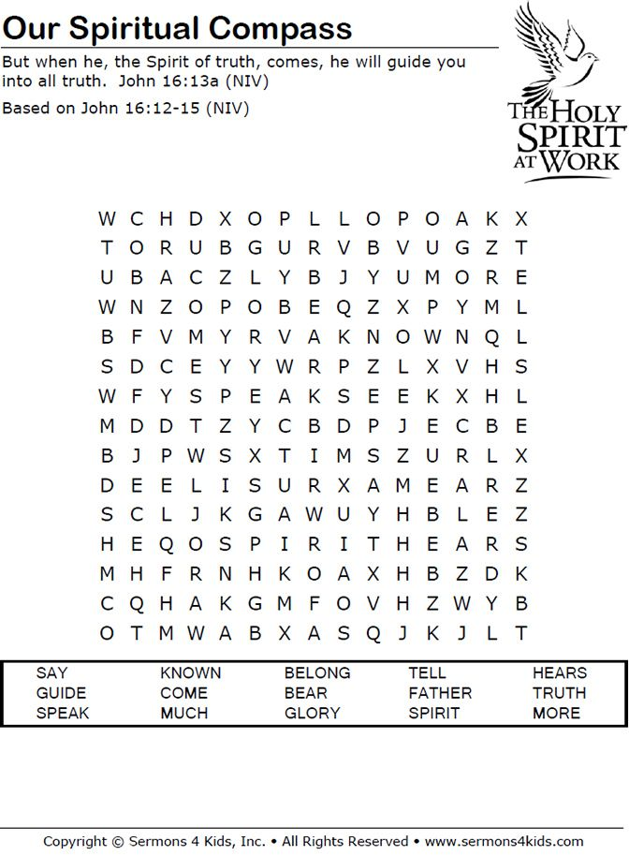

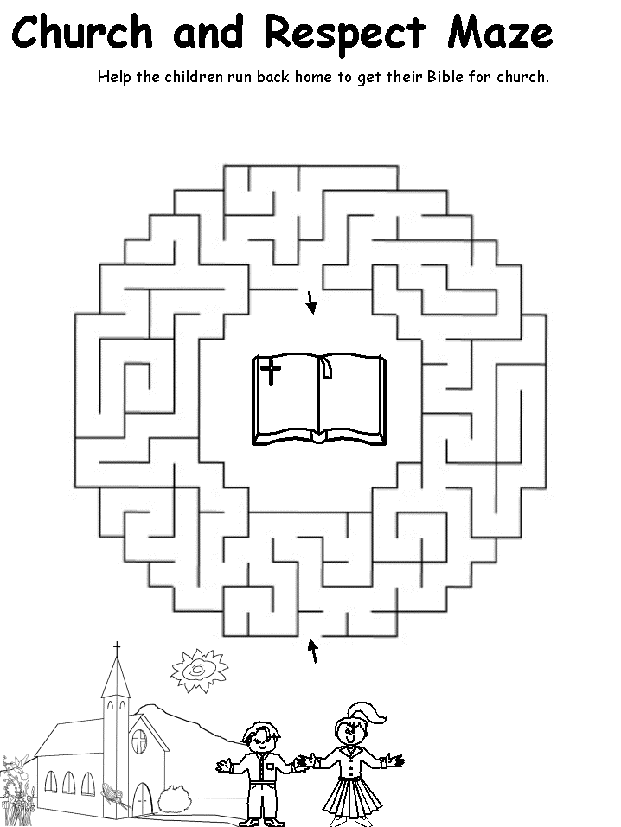

HOMEWORK: CHOSE ONE (OR TWO FOR OLDER STUDENTS) VERSE FROM PSALM 91 TO RECITE NEXT SUNDAY.

**Psalm 91 (NIV)**

**1**Whoever dwells in the shelter of the Most High will rest in the shadow of the Almighty. **2**I will say of the Lord, “He is my refuge and my fortress, my God, in whom I trust.” **3**Surely he will save you from the fowler’s snare and from the deadly pestilence. **4**He will cover you with his feathers, and under his wings you will find refuge; his faithfulness will be your shield and rampart. **5**You will not fear the terror of night, nor the arrow that flies by day, **6**nor the pestilence that stalks in the darkness, nor the plague that destroys at midday. **7**A thousand may fall at your side, ten thousand at your right hand, but it will not come near you. **8**You will only observe with your eyes and see the punishment of the wicked.

**9**If you say, “The Lord is my refuge,” and you make the Most High your dwelling, **10**no harm will overtake you, no disaster will come near your tent. **11**For he will command his angels concerning you to guard you in all your ways; **12**they will lift you up in their hands, so that you will not strike your foot against a stone. **13**You will tread on the lion and the cobra; you will trample the great lion and the serpent. **14**“Because he loves me,” says the Lord, “I will rescue him; I will protect him, for he acknowledges my name.**15**He will call on me, and I will answer him; I will be with him in trouble, I will deliver him and honor him.**16**With long life I will satisfy him and show him my salvation.”